STRATHFIELDSAYE NEWSLETTER – September 2021
Greening Australia – We received an email from Martin Potts from Greening Australia wanting to discuss options regarding the management of soil erosion, salinity and revegetation works which Greening Australia would like to undertake at Strathfieldsaye. Richard & I met with Martin and spent an hour or so walking the shoreline of Lake Wellington before we left Martin to wander through some of the paddocks east of swell point road. Martin has been back to the property since then and walked deeper into the areas heading towards the bombing target.
He thinks we should be able to get some funding for revegetation works and possibly look towards carbon storage credits in the future. I will be meeting with Martin again this week to show him around the Homestead and discuss possible projects. Any proposals Greening Australia put forward will be fully funded by grants applied for by Greening Australia and all works completed by Greening Australia personnel.
Wild Weather – With the coming of spring there has been some very strong winds and plenty of rain. There have been two large trees drop limbs across the driveway at different points. One of them Paul was able to remove with the use of the tractor and the other was the cypress tree near the homestead, which Richard cut up and removed also with the tractors help. The cypress trees behind the blacksmiths workshop have been a cause of concern for quite some time as they are very old and have been dropping limbs occasionally. There is a very large limb which fell down about a year ago and then another with the recent storms. These trees are all overgrowing the buildings in this area and putting a strain on the roofs. We have spoken to an arborist who will provide a suggested plan of what to remove and a quote on costs.
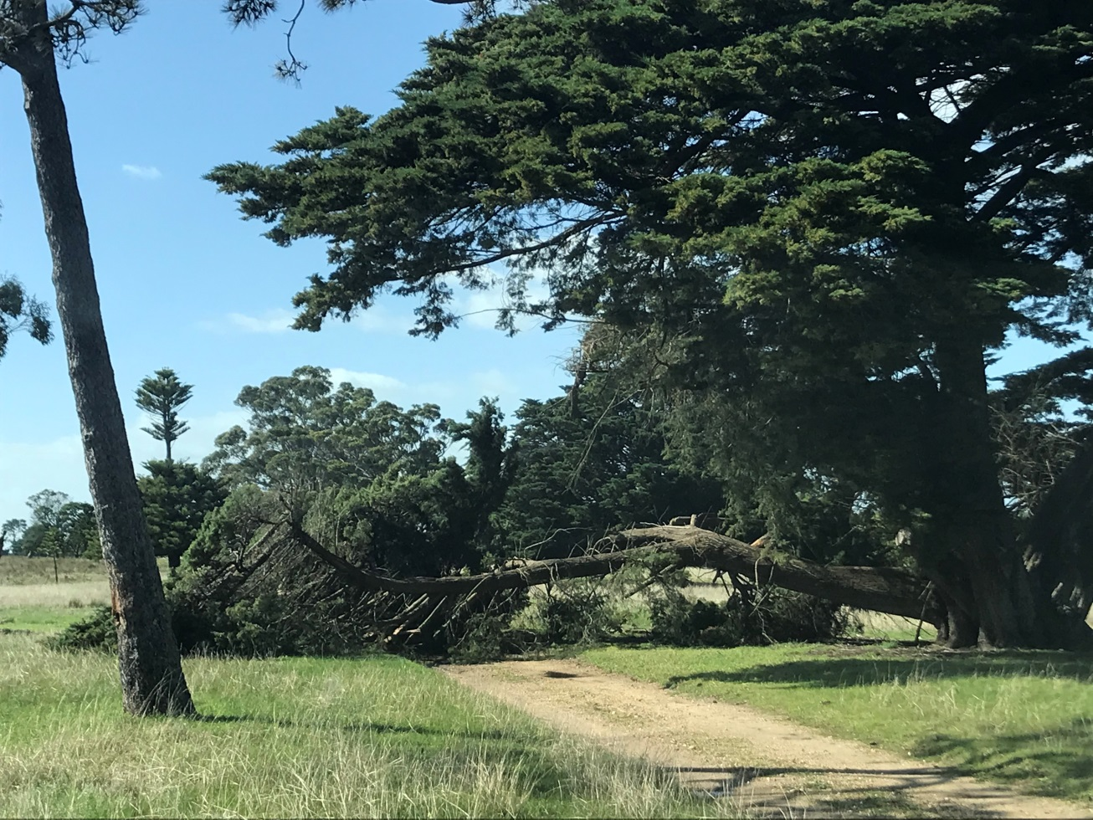Before
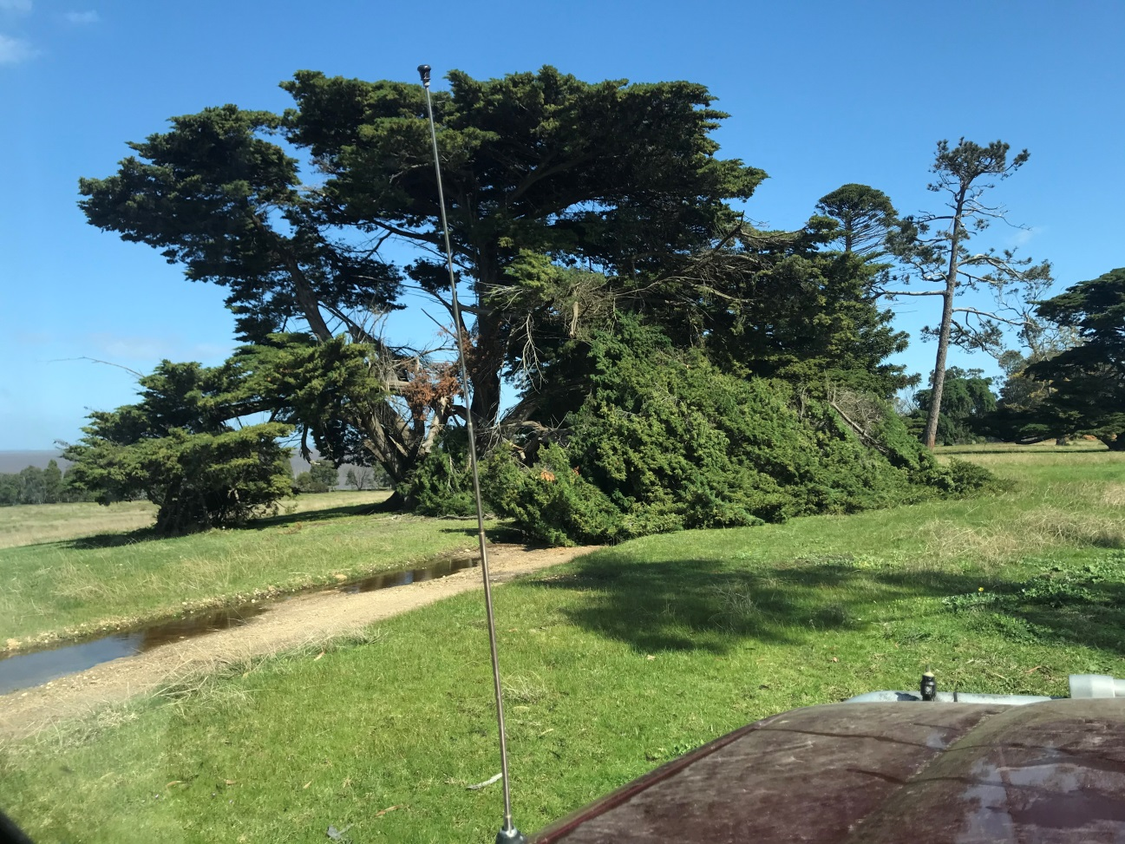Before
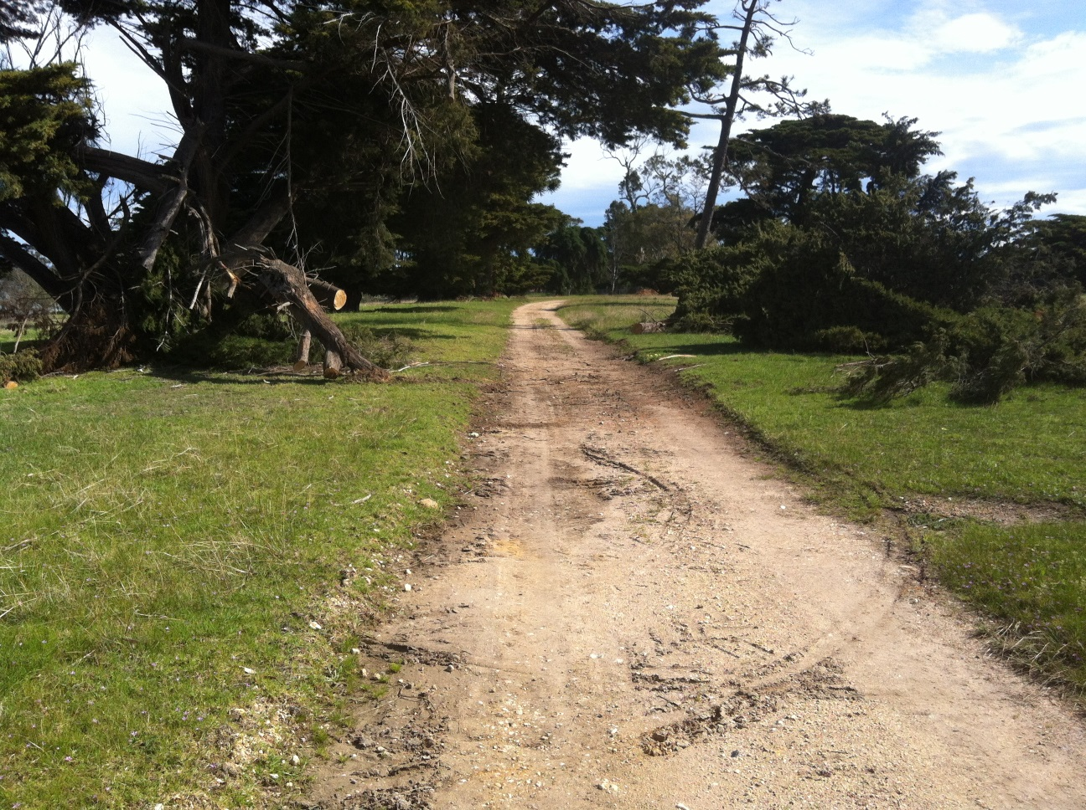After
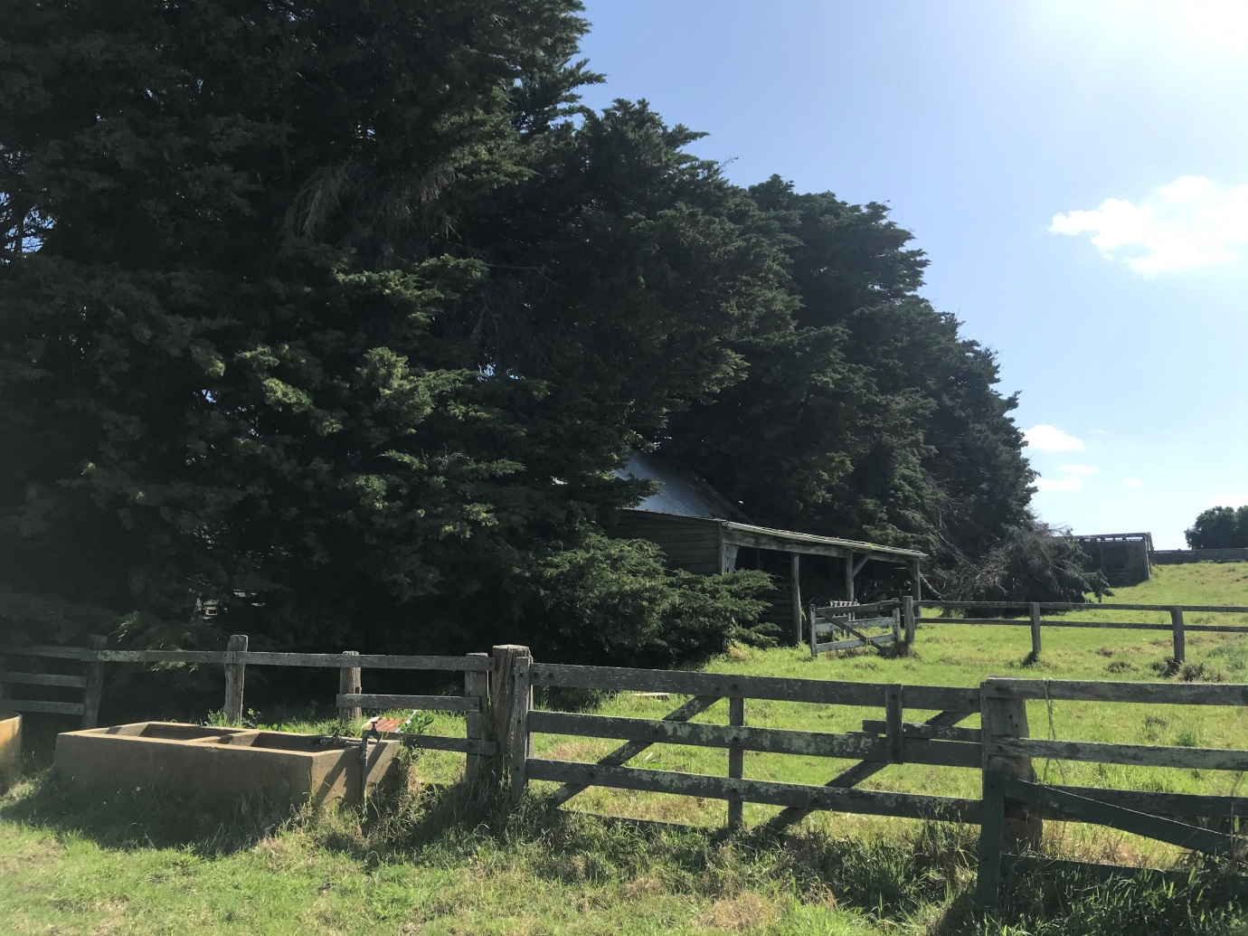
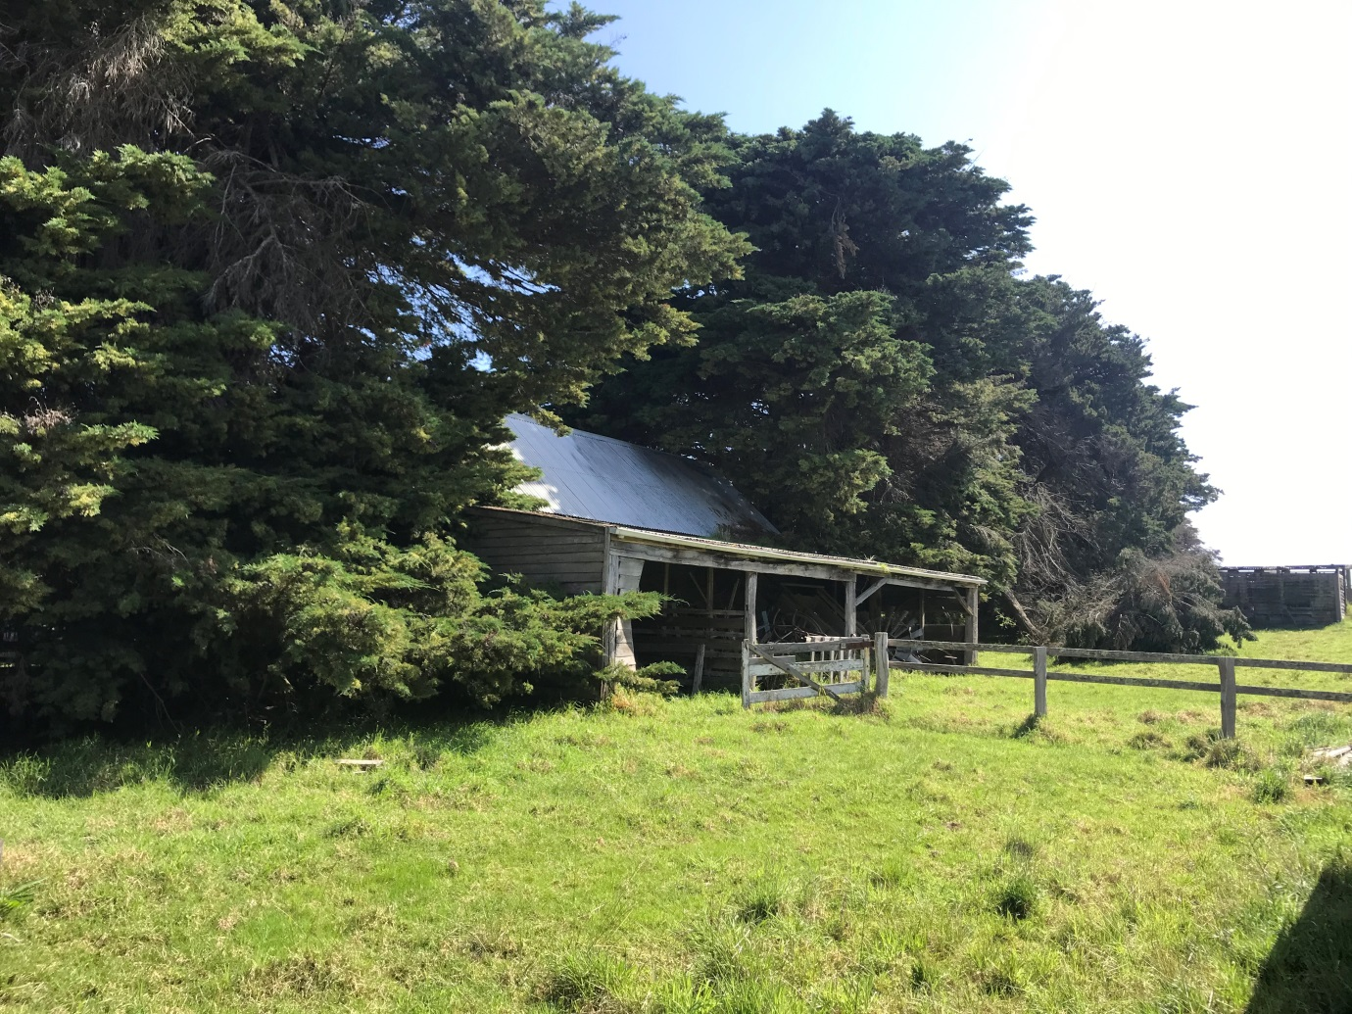
CTO Cattle – The heifers have all finished calving now. There were many successful births and so there are approximately 400 head of CTO cattle happily grazing the eastern paddocks.
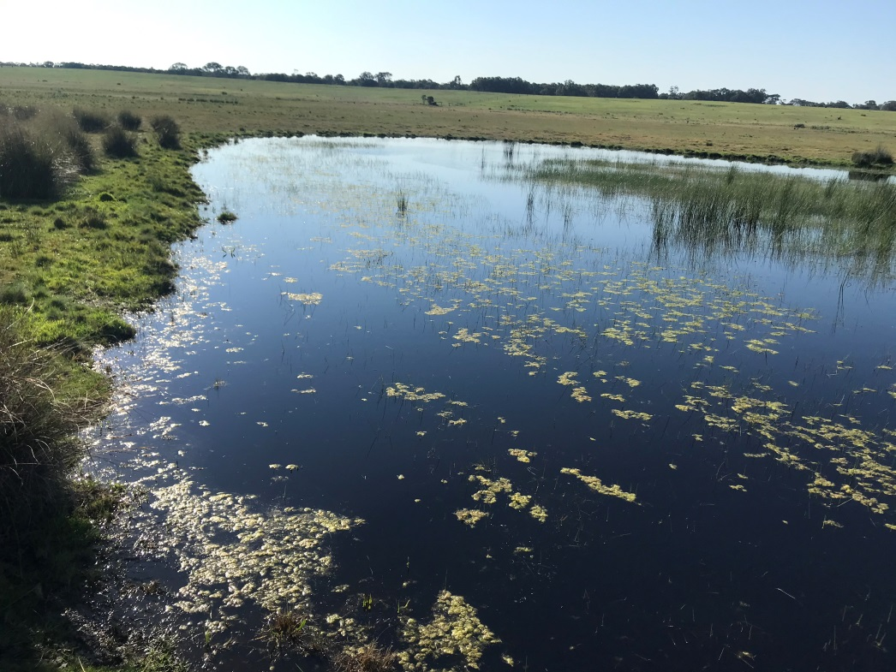
Rainfall – the wet weather has continued and looks to carry on for a while longer yet. July was rather dry and only saw a total of 10 mm, but August brought 70.4 mm and September up to the 14th has had 53 mm. This has given some areas of Strathfieldsaye a new life. Whilst inspecting paddocks at the start of September Rich & I came across a lagoon which we had not seen before. It is actually two bodies of water separated by a narrow wall covered in tussocks. It is in the ‘Bombing Range paddock’ I think. On the day we took Martin down to swell point the track was so wet and covered in water that we were not certain that we would get out of there again. Check out the video in the google drive.
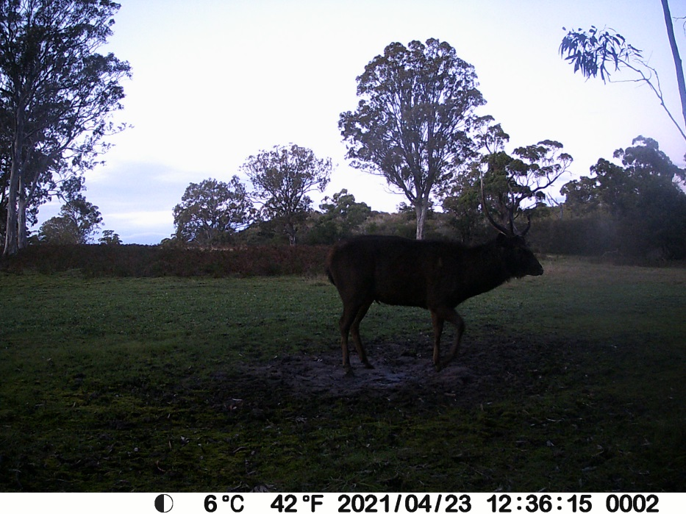
Trail Cam Photos – Both Danny & Paul keep trail cameras on the property to help track the wildlife. Danny reported that in August he noticed there had been a reduction in the number of hog deer appearing in his footage. However what he did see appear to be family groups which have young at foot. Kimberley had also reported a significant drop in the sightings of stags on her travels through the property. We do know there has been increased shooting activity and can only assume that some animals have been taken. There was an incident where the memory cards were removed from all of the cameras on one weekend. It can only be assumed that the person who took the memory cards but left the cameras was doing the wrong thing and knew it, and took the memory cards to prevent themselves from being identified.

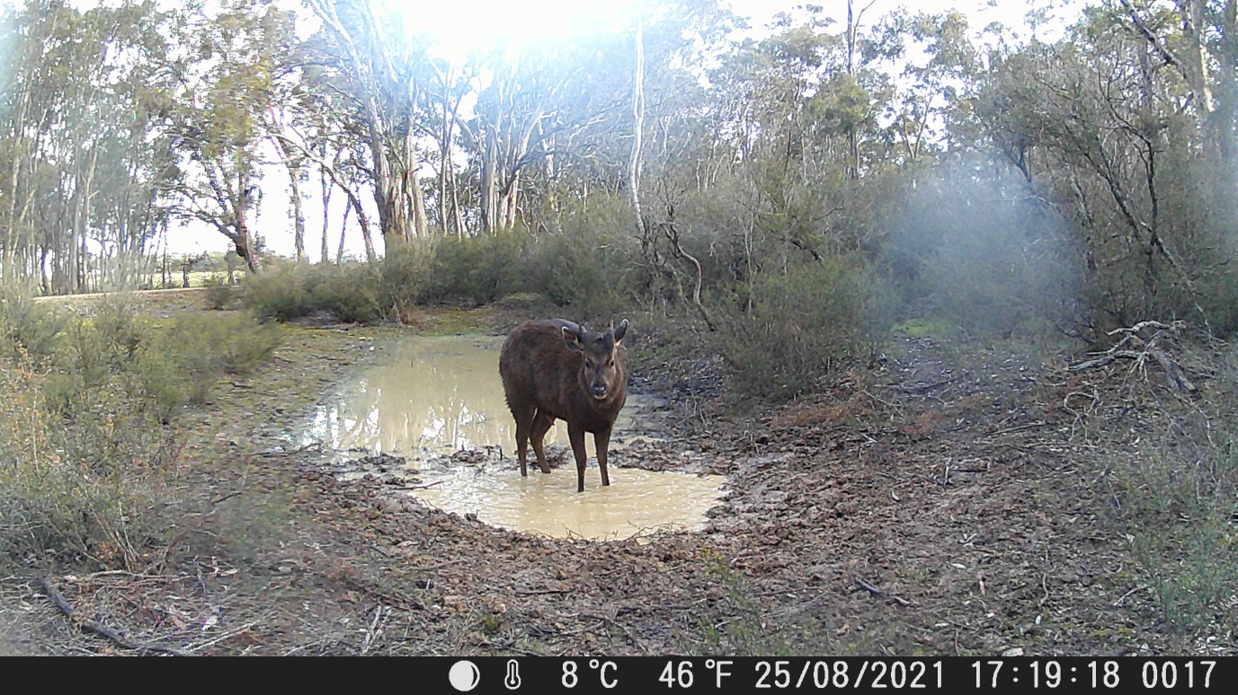

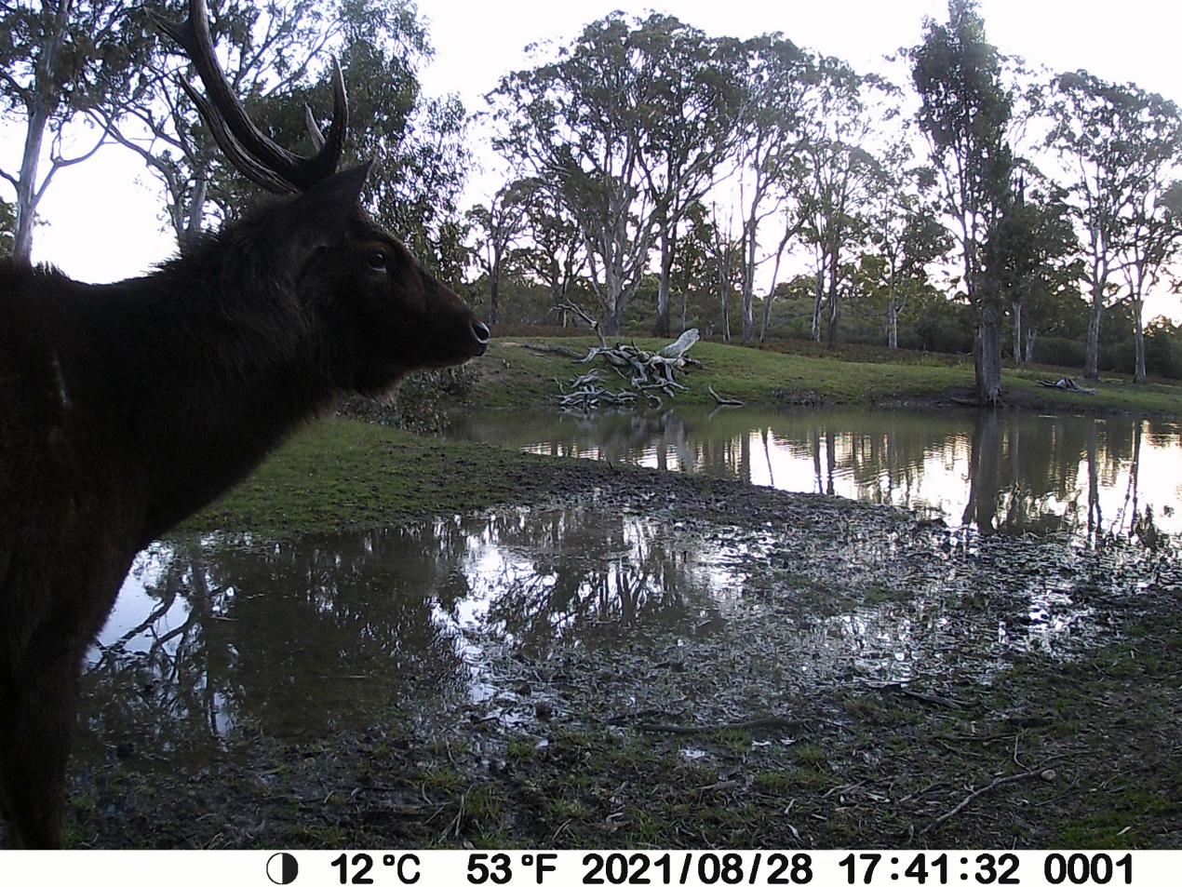

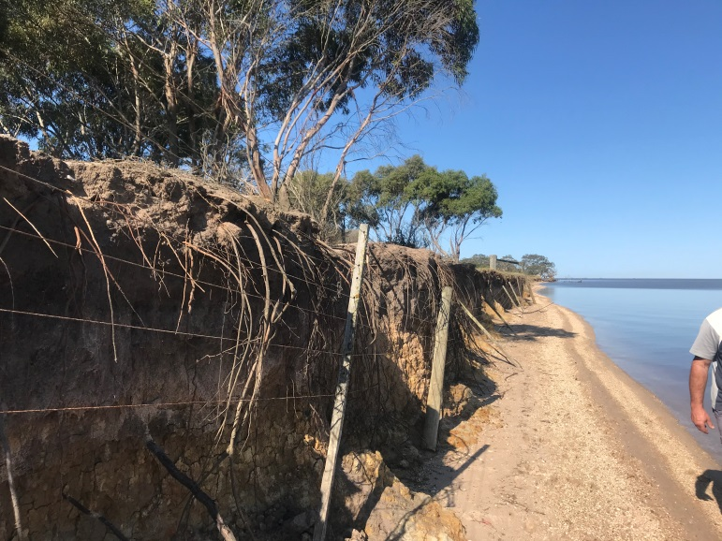

Lake Wellington shoreline fence – Unfortunately in the last storm the remaining parts of the bank were washed away and the fence now sits on the beach. You can see from these photos the change in just 6 months where the fencing stays no longer have any bank to rest on.
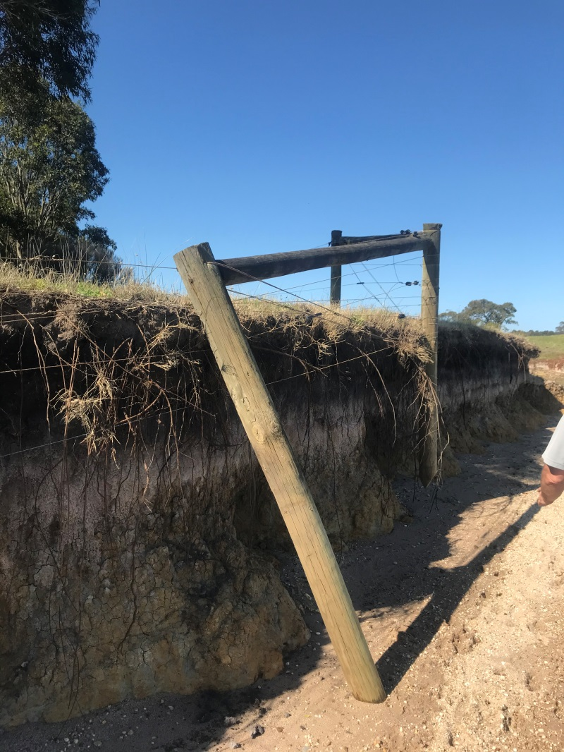
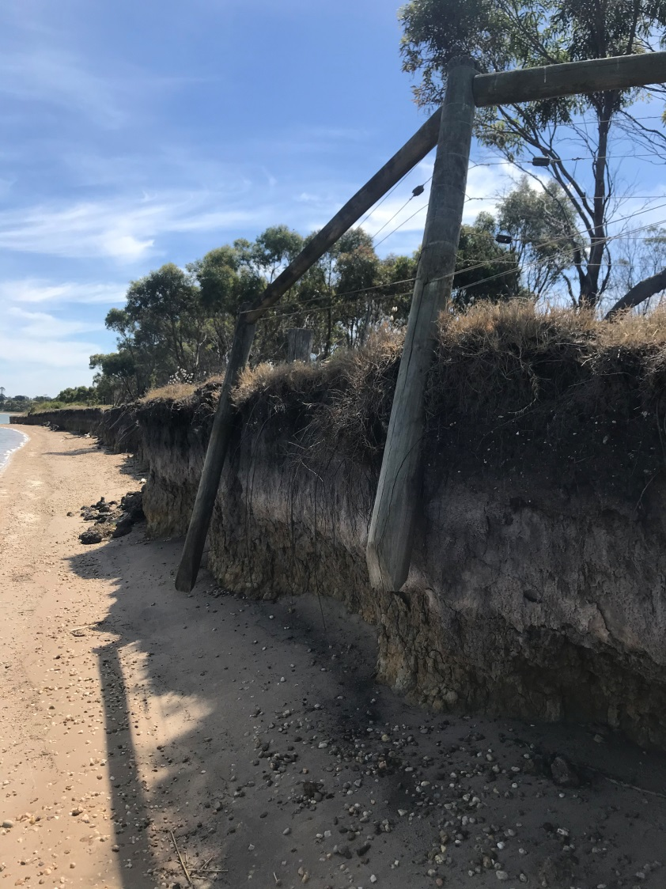
9 March 2021

2 September 2021
Community Groups – The local Army Cadet Unit have requested to hold their annual camp at Strathfieldsaye this year. Usually the cadets would join up with cadets from all over Victoria and have their camp at Puckapunyal. This is not possible this year and so the local unit from Sale consisting of approximately 15 teenagers and 3 adult staff will be staying and training at Strathfieldsaye for 4 days at the end of September. Rich will be managing this group.
The Bairnsdale Four Wheel drive club have requested to hold their annual Christmas function at Strathfieldsaye this year. Some members of the club have been to visit the property a few years ago and they would like the opportunity to show other members this amazing place. They expect to camp on or near the lake front from Friday 26th November to Sunday 28th November. Rich & I will be in attendance during this period and hope to conduct tours for the members including around the homestead; a walking trip to the Perry River Reserve and a driving trip to the bombing target. The club usually has approximately 20 vehicles, which includes about 40 members attending their Christmas function. All members will provide all their own accommodation.
The Maffra & District Police Social Club have requested to hold their annual Christmas function at Strathfieldsaye again this year. They first met for a function in January 2021 and would like the opportunity to do so again this December. They expect to have a bbq dinner and camp overnight along the lake front. Usually approximately 15 police embers and their partners attend this function with about 6 – 8 staying overnight.
The Strathfieldsaye volunteers Group would also like to hold a function before Christmas. We hope to line this up with Pam’s return, so have not at this stage set a date.

